**Curriculum Vitae (C.V)**

**I. General information:**

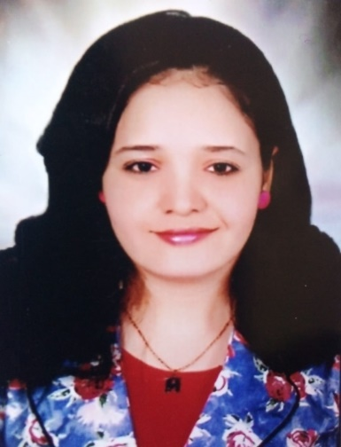

**Name:-** Martha Melek labeib Gerges  
**Birth date:-**17/7/1989  
**Civil status:-** married.  
**Present position:-** Lecturer  
**Address:-** Assiut.  
**Tel. No. :-** 01288270387  
**E-mail :**marthagerges17@yahoo.com  
**Academic email:-** martha @ aun.edu.eg  
**II-Educational qualification:-**

|  |  |  |
| --- | --- | --- |
| **Institution** | **Years** | **Scientific degree** |
| Assiut university | 2011 | Baccalaureate |
| Assiut university | 2017 | Master degree in Gerontological nursing |
| Assiut university | 2021 | Doctorate degree in Gerontological nursing |

**III-Hierarchy academic career:-**

|  |  |  |
| --- | --- | --- |
| **Institution** | **Years** | **Occupation** |
| Assiut university | 2012 | Demonstrator |
| Assiut university | 2018 | Assistant Lecturer |

* + **IV. Receiving training program of quality about:**  
    1- Methods of Scientific Research  
    2- Scientific Publishing  
    3- English language  
    4- How to write a research project competitive  
    5- The system of credit hours  
    **V-Activities in the field of quality management systems / education**  
    **development projects:**
  + Quality Standards in Teaching 1
  + University administration
  + Strategic Planning Course
  + Introducing the International Academic Standards (ASR) for the postgraduate stage
  + Relative weight of the exam paper
  + Introducing the Academic Standard Standards (ASR) for a bachelor's degree holder and applying them in educational programs
  + Introducing the college's information unit services
  + How to Quadruple Analysis (SOWT)
  + Electronic course activation cycle
  + A course on foresight about the future
  + A course on learning outcomes
  + Attending a training course on the use of electronic databases 2020
  + Attending a training course on the use of the knowledge bank and academic mail 2020
  + Attending a workshop on scientific writing and scientific research 2020
  + Attending a workshop on electronic exams 2019
  + Attending a training course on examination systems and student evaluation
  + Attending a training course on advanced e-learning
  + Attending a training course on quality standards in the teaching process
  + Attending a training course on the applications of information technology in teaching
  + Participation in the standard of teaching and learning
  + International: Participate in The First International Scientific Conference for Nursing Colleges in Southern Upper Egypt, 25-25/2/2020 (quality education and health).
    - **VI-Activities that are related to the educational process and**  
      **community service.**
    - Teaching practical sections to undergraduate students
    - Participation in first aid courses for students and petroleum companies
    - Participation in the Elderly sitter course
    - Attending a training course on organizing scientific conferences
    - Awareness seminars on diabetes, Alzheimer's and high blood pressure
    - How to create and use an account on research gate, Microsoft team, Egyptian knowledge bank, zoom, Google meeting, Google forms, Moodle, Endnote, Mendely, webex, Microsoft office 365, Advanced power point and word.
    - Courses specification for undergraduate students
    - Courses specification for doctor's program courses
    - Visits to the elderly club and give guidance for the elderly to prevent disease.
    - Seminars for the elderly (elderly nutrition- the immune system of the elderly- Alzheimer’s disease).
    - Provide guidance and health education for the elderly in the Outpatient Department of Internal Medicine in University Hospital.
    - Clinical training 4th year student in Department of Chest Diseases